

**American International University-Bangladesh**

**Faculty of Science and Information Technology**

**Department of Computer Science**

**Object Oriented Analysis and Design [L]**

|  |
| --- |
| **Semester: Spring 2020-21** |

**Group - 1**

|  |  |  |
| --- | --- | --- |
| Student ID | Student Name | Contribution in course feedback |
| 19-41283-3 | Nafiz Ahmed | 25% |
| 19-41289-3 | Anik Kumar Saha | 16.67% |
| 19-41292-3 | Ayesha Akhtar | 16.67% |
| 19-41293-3 | Tonmoy Saha Choyon | 25% |
| 19-41322-3 | Raiyan Ahmed | 16.67% |

**Course feedback name**

**Online Class Exercise Management System**

**General Scenario:**

This Course feedback is about **Online class exercise management system**. As we all have been dealing with Covid for a very long time, it has become very crucial to conduct semesters on online platforms. And to do so a fixed evaluation process is needed. So, this is what the Course feedback is for. Here faculties and students are managed by the university administrator. Both have their individual accounts. Faculties can assign class tasks with the help of online software where students are asked to attend those tasks. And the good thing is, with the help of answered stored in Database, student can know their obtained marks moment after they submit their answers. So, this how an online class exercise can be conducted.

**Use case diagram scenario:**

This is an **Online Class Exercise Management System**. In order to assign class, exercise a **faculty** must login to the system. When a **faculty** assigns a class exercise, he/she sets appearing time, closing time, add questions & select answers. In order for a **student** to attend class exercise a **student** has to log into the system, has to turn on his/her video camera and open the assigned class exercise link which is assigned by the **faculty** and can check results afterwards. The accounts are verified by the **database**. When a **student** opens the assigned class exercise, he/she can confirm that class exercise has appeared on his/her device and a **student** has to answer every question in order to submit the answer script. **Database** verifies the answer given by the student with the answers selected by the faculty and evaluates them. To be able to do any kind of operation in this system account of a user is verified by the **database**. 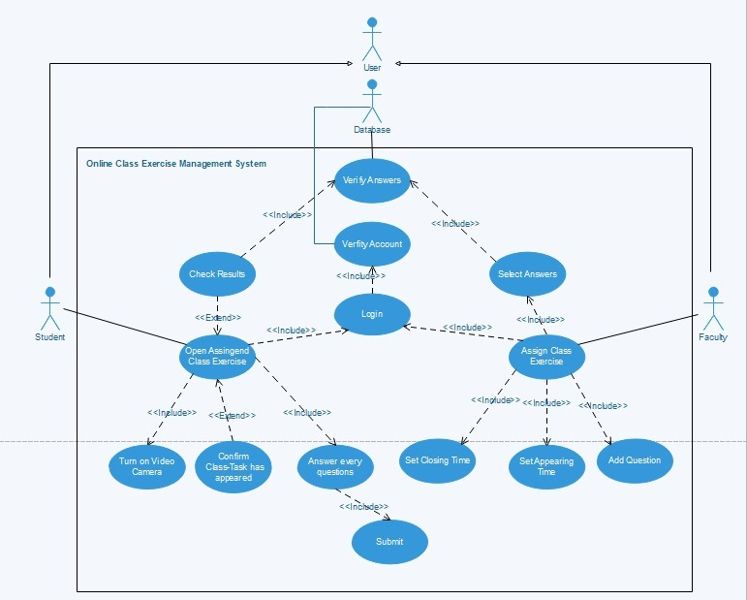

**Class diagram scenario:**

**Faculties** and the **students** use **application**. A **Faculty** can teach in one **class** at a time. All **students** attend the same class. **Students** can turn on their **video camera**. **Faculty** assigns only one **exercise link** and **students** open that link. A **faculty** can set one or more **answer script**. A **student** can submit only one response at a time. Submitted **answer scripts** are stored in **database**. **Faculty** receives answers from the **database**. **Faculty** returns the scripts to the **students**. 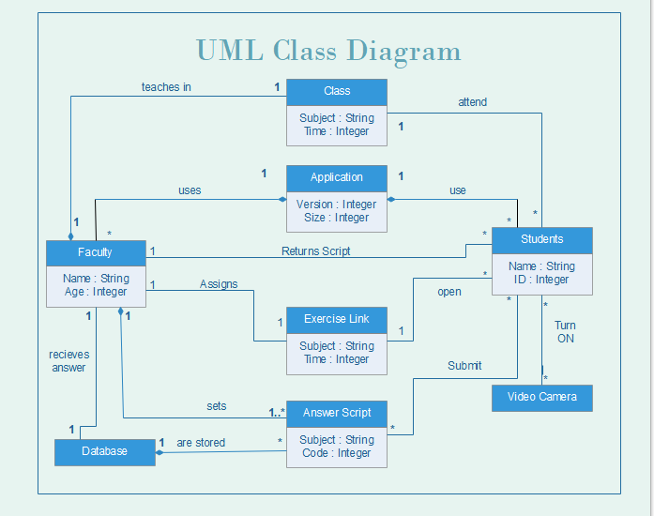

**Sequence diagram scenario:**

A **student** opens an application and enters login details. **Database** verifies the account. After a successful login, a meeting appears in the device, student joins the meeting and opens his/her video camera which is accessed by the **device**. A **student** opens the class exercise and after completing turns in his/her response which is kept in the **database**, **system** cross-checks between the answer script of the **student** and the answers in the **database** and evaluates them. A **student** can check his/her answer script using the **device** and after closing his/her camera a **student** can leave the class and logout from the application. Application will be closed from the **device**.

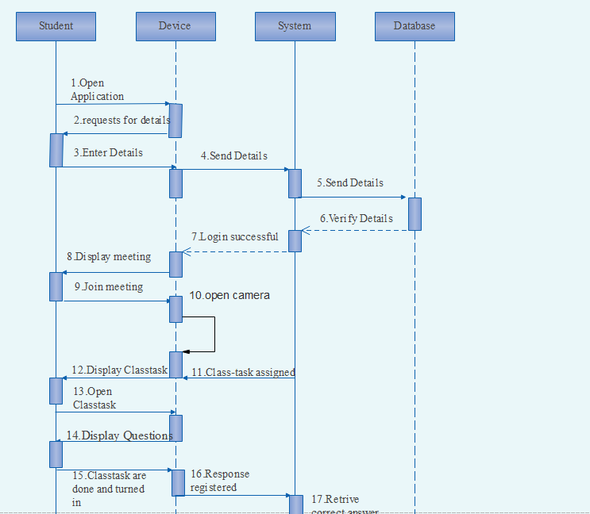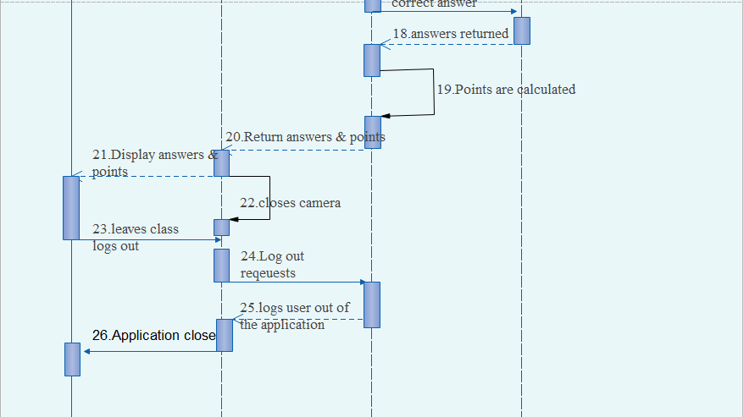

**State-chart diagram scenario:**

Firstly, questions are prepared by the faculty. **Class exercise** starting time, starting date and closing time are set simultaneously. Questions are saved as draft until starting time. If the starting time is reached, **class exercise** is assigned. Form accepts responses until closing time. Responses are saved, checked and evaluated at the same time. And finally, **class exercise** is returned. 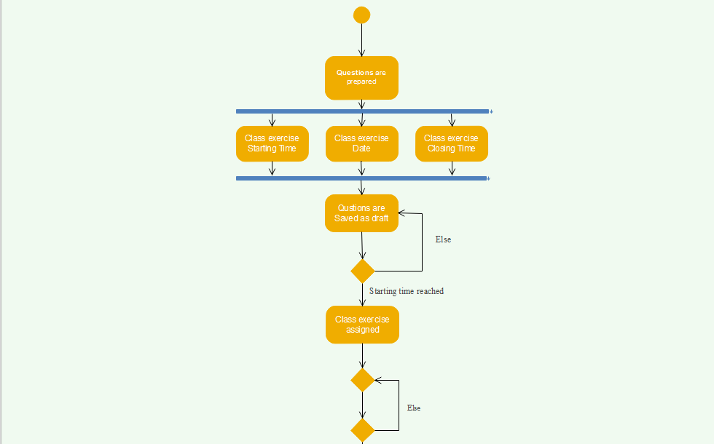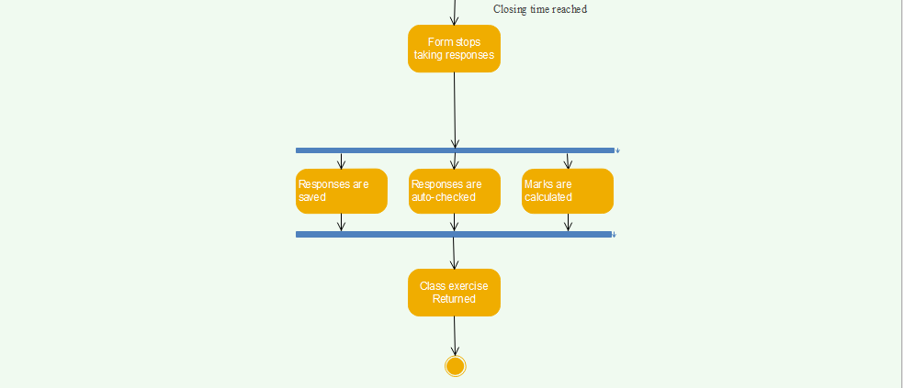

**Activity diagram scenario:**

In an online class exercise system, a **faculty** opens the application and logs into it. The account is verified by the database. If login is successful, **faculty** can start a class otherwise login bar appears again. When **faculty** starts a class, a meeting appears in the application. **Faculty** sets questions and the duration at the concurrently. **Faculty** assigns class exercise link which appears in the application chat. **Application** takes submission until closing time and sends the script of the students to the **database**. **Database** sends the answer script to the **application** and the **application** evaluates the marks. **Faculty** returns the script & the evaluated class exercise is displayed in the **application**. **Faculty** can leave the class and logs out.

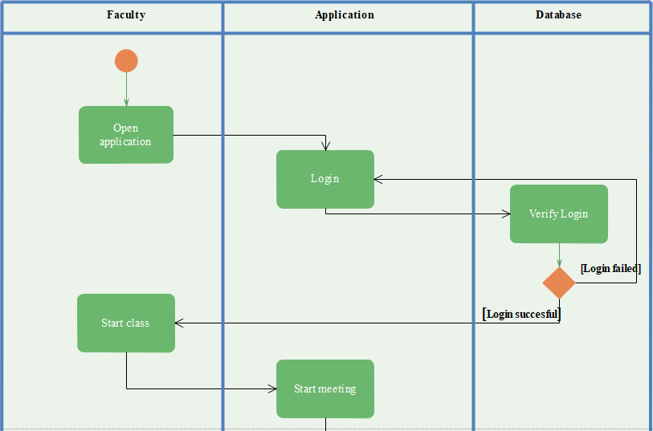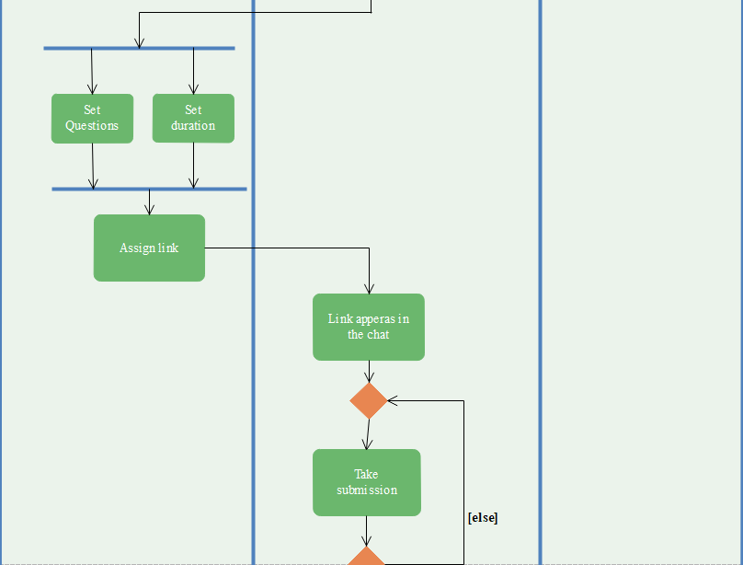

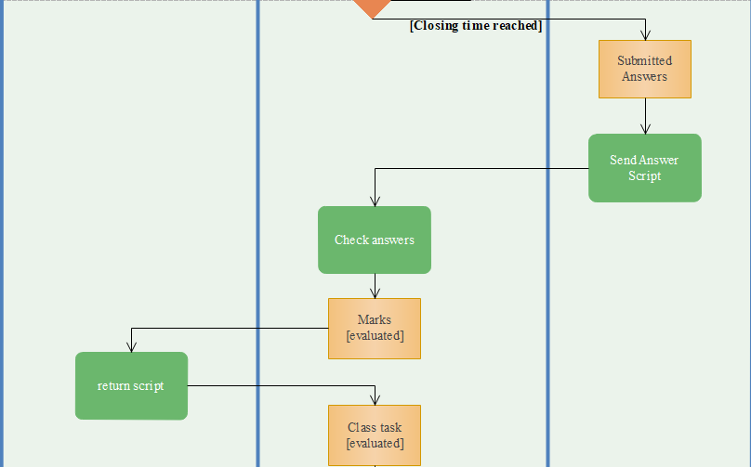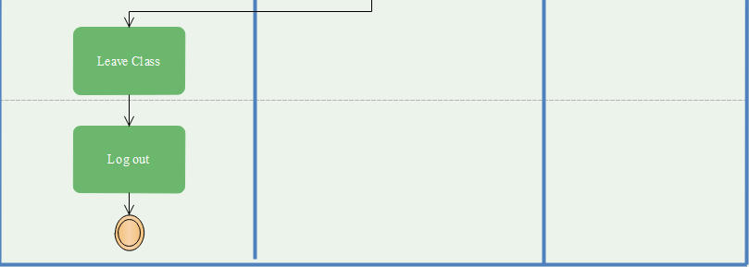

**COCOMO (COnstructive COst MOdel) II:**

**Software type:** Semi-Detached

**SLOC =** 6000 (Assumption)

For Semi-Detached Course feedback type,

**Coefficient<Effort Factor> =** 3.0

**P =** 1.12

**T =** 0.35

So,

**Effort = PM = Coefficient<Effort Factor>*(SLOC/1000) ^P**

**=** 3*(6000/1000) ^ 1.12

**=** 22.318

**Development time = DM = 2.50*(PM)^T**

**=** 2.50*(22.318) ^0.35

**=** 7.413

**Required number of people = ST = PM/DM**

**=** 22.318/7.413

**=** 3.011 ~ 4

**The End**